LIBRARY MANANGEMENT SYSTEM

Submitted to:
INSAN DEGREE COLLEGE
Under
UNIVERSITY OF MAULANA MAZHARUL HAQUE ARABIC & PERSIAN


Submitted by:

Roll no:-16190020045
Md. Aqueel Alam

Roll no:-161900200023
Md. Wasim Akram

Roll no:-16190020028
Krishna Thakur

Roll no:-161900200018
Md. Rizwan Alam

Contents

- Declaration
- Acknowledgement
- Title of the Project
- Introduction of the project
- Objectives
- Tools and platform used
- Project planning and Scheduling
- System Analysis and Design
- Feasibility analysis
- Data Flow Diagram(DFD)
- Entity Relationship Diagram
- Software Requirement and specification(SRS)
- Database Table(Data Dictionary)
- Model
- Design Snapshots
- Coding Snapshots
- Testing
- Bibliography

DECLARATION

We, do hereby declare that this project entitled “LIBRARY MANAGEMENT SYSTEM” Submitted by us. For the partial fulfillment of the Bachelors of Computer Application (B.C.A) to UNIVERSITY OF MAULANA MAZHARUL HAQUE ARABIC & PERSIAN is an authentic and original work done by us.
We, further state and declare that this project is our genuine work has not be submitted whether to this University or to any other University for the fulfillment of the requirement of any course of study.

Project Members:
Md. AqueelAlam …………………………………………
Md. Wasim Akaram ………………………………………….
Md. Rizwan Alam …………………………………………..
Krishna Thakoor …………………………………………..

BONAFIDE CERTIFICATE

This is to certify that the project report entitled LIBRARY MANAGEMENT SYSTEM submitted to UNIVERSITY OF MAULANA MAZHARUL HAQUE ARABIC & PERSIAN in partial fulfillment of the requirement for the award of the degree of BACHELOR OF COMPUTER OF APPLICATION (B.C.A), is a Bonafide and originally carried out by MD Aqueel Alam , Roll no 161900200045, under my supervision during the Academic year 2018 in I.D.C affiliated to UNIVERSITY OF MAULANA MAZHARUL HAQUE ARABIC & PERSIAN,PATNA.

INTERNAL GUIDE

PRASANJEET GHOSH
LECTURER

BONAFIDE CERTIFICATE

This is to certify that the project report entitled LIBRARY MANAGEMENT SYSTEM submitted to UNIVERSITY OF MAULANA MAZHARUL HAQUE ARABIC & PERSIAN in partial fulfillment of the requirement for the award of the degree of BACHELOR OF COMPUTER OF APPLICATION (B.C.A), is a Bonafide and originally carried out by Md.Wasim Akram ,Roll no 161900200023 , under my supervision during the Academic year 2018 in I.D.C affiliated to UNIVERSITY OF MAULANA MAZHARUL HAQUE ARABIC & PERSIAN,PATNA.

INTERNAL GUIDE

PRASANJEET GHOSH
LECTURER

BONAFIDE CERTIFICATE

This is to certify that the project report entitled LIBRARY MANAGEMENT SYSTEM submitted to UNIVERSITY OF MAULANA MAZHARUL HAQUE ARABIC & PERSIAN in partial fulfillment of the requirement for the award of the degree of BACHELOR OF COMPUTER OF APPLICATION (B.C.A), is a Bonafide and originally carried out by Md Rizwan Alam ,Roll no 161900200018 , under my supervision during the Academic year 2018 in I.D.C affiliated to UNIVERSITY OF MAULANA MAZHARUL HAQUE ARABIC & PERSIAN,PATNA.

INTERNAL GUIDE

PRASANJEET GHOSH
LECTURER

BONAFIDE CERTIFICATE

This is to certify that the project report entitled LIBRARY MANAGEMENT SYSTEM submitted to UNIVERSITY OF MAULANA MAZHARUL HAQUE ARABIC & PERSIAN in partial fulfillment of the requirement for the award of the degree of BACHELOR OF COMPUTER OF APPLICATION (B.C.A), is a Bonafide and originally carried out by Krishna Thakur ,Roll no 161900200028 , under my supervision during the Academic year 2018 in I.D.C affiliated to UNIVERSITY OF MAULANA MAZHARUL HAQUE ARABIC & PERSIAN,PATNA.

INTERNAL GUIDE

PRASANJEET GHOSH
LECTURER

ACKNOWLEDGEMENT

First of all, We like to express our gratitude to almighty God for his blessings that he helped us to complete my project with full confident.
We are very grateful to my teacher Mr. Prasanjeet Ghosh, lecturer,Insan Degree college for his valuable contribution to the project work by supervising the work and giving encouragement. Without his help it is impossible for us to finish this project properly in time.
We would like to thank our parents and friends who encourage us and helped us a lot to finish our project successfully.

TITLE OF THE PROJECT


LIBRARY MANGEMENT SYSTEM
FOR
STUDENT & TEACHER

INTRODUCTION

Library Management System is basically updating the manual library system into an internet-based application so that the users can know the details of their accounts, availability of books and maximum limit for borrowing.

The project is specifically designed for the use of librarians and library users. The product will work as a complete user interface for library management process and library usage from ordinary users. Library Management System can be used by any existing or new library to manage its books and book borrowing, insertion and monitoring. It is especially useful for any educational institute where modifications in the content can be done easily according to requirements.

The project can be easily implemented under various situations. We can add new features as and when we require, making reusability possible as there is flexibility in all the modules.
The language used for developing the project is PHP as it is quite advantageous than other languages in terms of performance, tools available, cross platform compatibility, libraries, cost (freely available), and development process.

This is made computerized to reduce human made errors and to increase the efficiency. The main aim of this library management system project is to reduce human efforts. The maintenance of the records is made easy and all the records are stored in the Sql database.

OBJECTIVES

The main objective of this project is to provide a friendly environment to maintain the details of books and library members. The main purpose of this project is to maintain easy circulation system using computers and to provide different reports. This project describes the hardware and software interface requirements using ER diagrams and UML diagrams. The objectives are as follows:
• Online book issue.
• Request column for librarian for providing new books.
• A separate column for digital library.
• Student login page where student can find books issued by him/her and date of return.
• A search column to search availability of books.
• A teacher login page where teacher can add any events being organized in the college.
And important suggestions regarding books.
Online notice board about the workshop.

TOOLS AND PLATFORM
- SOFTWARE CONFIGURATION:
This WEBSITE is developed using php as front end. MYSQL as the back end to store the database.

Operating System: Windows NT, windows 98, Windows XP, window 7 window 8
Language: PHP, HTML, CSS (FRONT END)
Database: MYSQL (back end)

- Hardware Configuration:
Processor: Pentium(R) Dual-core CPU
Hard Disk: 40GB
RAM: 256 MB or more
External Interface Requirement
GUI
The software provides good graphical interface for the user and the administrator can operate on the system, performing the required task such as create, update, viewing the details of the book.
- It allows user to view quick reports like Book Issued/Returned in between particular time.
- It provides stock verification and search facility based on different criteria.
- The user interface must be customizable by the administrator
- All the modules provided with the software must fit into this graphical user interface and accomplish to the standard defined
- The design should be simple and all the different interfaces should follow a standard template
- The user interface should be able to interact with the user management module and a part of the interface must be dedicated to the login/logout module
Login Interface:-
In case the user is not yet registered, he can enter the details and register to create his account. Once his account is created he can ‘Login’ which asks the user to type his username and password. If the user entered either his username or password incorrectly then an error message appears.
Search:-
The member or librarian can enter the type of book he is looking for and the title he is interested in, then he can search for the required book by entering the book name.
Categories View:-
Categories view shows the categories of books available and provides ability to the librarian to add/edit or delete category from the list.
Librarian’s Control Panel:-
This control panel will allow librarian to add/remove users; add, edit, or remove a resource. And manage lending options.
System Features
The users of the system should be provided the surety that their account is secure. This is possible by providing:-
- User authentication and validation of members using their unique member ID
- Proper monitoring by the administrator which includes updating account status, showing a popup if the member attempts to issue number of books that exceed the limit provided by the library policy, assigning fine to members who skip the date of return
- Proper accountability which includes not allowing a member to see other member’s account. Only administrator will see and manage all member accounts

Other Non-functional Requirements
Performance Requirement
The proposed system that we are going to develop will be used as the Chief performance system within the different campuses of the university which interacts with the university staff and students. Therefore, it is expected that the database would perform functionally all the requirements that are specified by the university.
- The performance of the system should be fast and accurate
- Library Management System shall handle expected and non-expected errors in ways that prevent loss in information and long downtime period. Thus it should have inbuilt error testing to identify invalid username/password
- The system should be able to handle large amount of data. Thus it should accommodate high number of books and users without any fault

Safety Requirement
The database may get crashed at any certain time due to virus or operating system failure. Therefore, it is required to take the database backup so that the database is not lost. Proper UPS/inverter facility should be there in case of power supply failure.

Security Requirement
- System will use secured database
- Normal users can just read information but they cannot edit or modify anything except their personal and some other information.
- System will have different types of users and every user has access constraints
- Proper user authentication should be provided
- No one should be able to hack users’ password
- There should be separate accounts for admin and members such that no member can access the database and only admin has the rights to update the database.

Requirement attributes
- There may be multiple admins creating the project, all of them will have the right to create changes to the system. But the members or other users cannot do changes
- The project should be open source
- The Quality of the database is maintained in such a way so that it can be very user friendly to all the users of the database
- The user be able to easily download and install the system

User Requirement
The users of the system are members and Librarian of the university who act as administrator to maintain the system. The members are assumed to have basic knowledge of the computers and internet browsing. The administrators of the system should have more knowledge of the internals of the system and is able to rectify the small problems that may arise due to disk crashes, power failures and other catastrophes to maintain the system. The proper user interface, user manual, online help and the guide to install and maintain the system must be sufficient to educate the users on how to use the system without any problems.
The admin provides certain facilities to the users in the form of:-
- Backup and Recovery
- Forgot Password
- Data migration i.e. whenever user registers for the first time then the data is stored in the server
- Data replication i.e. if the data is lost in one branch, it is still stored with the server
- Auto Recovery i.e. frequently auto saving the information
- Maintaining files i.e. File Organization
- The server must be maintained regularly and it has to be updated from time to time

Other Requirements
Data and Category Requirement
There are different categories of users namely teaching staff, Librarian, Admin, students etc. Depending upon the category of user the access rights are decided. It means if the user is an administrator then he can be able to modify the data, delete, append etc. All other users except the Librarian only have the rights to retrieve the information about database. Similarly there will be different categories of books available. According to the categories of books their relevant data should be displayed. The categories and the data related to each category should be coded in the particular format.

PERT CHART

PERT (Project Evaluation and Review Technique) charts consists of a network of boxes and arrows. The boxes represent activities and arrow represent task dependencies. PERT chart represent the statistical variations in the project estimates assuming a normal distribution. Thus, in a PERT chart instead of making a single estimate for each task, pessimistic, likely, and optimistic estimates are made. The boxes of PERT charts are usually annotated with the pessimistic, likely, and optimistic estimates for every task. Since all possible completion times between the minimum and maximum duration for every task has to be considered, there is not one but many critical paths, depending on the permutations of the estimates for each tasks. This makes critical path analysis in PERT charts very complex. A critical path in a PERT charts is shown by using thicker arrows. PERT charts are more sophisticated form of activity chart. The actual duration might vary from the estimated durations, the utility of the activity diagram are limited. PERT chart is useful in monitoring the timely progress of activities. Also it is to identify parallel activities in project using a PERT chart. Project managers need to identify the parallel activities in a project for assignment to different developer.

Design database

Specification
Finish
Integrate and test
Write user manual
Code GUI part
Design GUI part
Code database part
FEASIBILITY STUDY

Feasibility is the determination of whether or not a project is worth doing. The process followed is making this determination is called a Feasibility Study. This type of study determines if a project can and should be taken. Once it has been determined that a project is feasible, the analyst can go ahead and prepare the project specification which finalizes project requirement. There are various types of feasibility. The software which has been developed undergoes three feasibility analysis phases. They are- Technical Feasibility, Operational Feasibility, Economic Feasibility, and Social Feasibility.

Technical Feasibility:
A study of function, performance, and a constraint that may affect the ability to achieve an acceptable system is the technical feasibility.
MYSQL has been chosen as back end for the development of the project that provides the best option for development of error free, and secure database development. As front endPHP has been chosen that is provided by the Microsoft for the creation of platform independent application
Economic Feasibility:
This feasibility checks whether the software development is completed at a given cost constraint, and the minimum cost to attain a certain system. Ordinary P2 computer with 128 MB RAM is sufficient to run this software. The organization is required to purchase the Windows OS, BOOTSTRAP framework and MYSQL.
Operational Feasibility:
It is mainly related to human organization and political aspects, the point to be taken care are: What changes will be brought up in the system? What new skills will be required?
This software is designed in such a way that it provides a complete insight with the minimum of resources. It provides the users with services and quality they expect. It frees us from the manual work load, it increases speed and efficiency.
Social Feasibility:
It is a determination of whether a proposed project will be acceptable to the people or not. Our software is very “user friendly” and has been configured with taking in experienced computer users in mind.

DATA FLOW DIAGRAM

A DFD is a graphical model of a system that shows the different functional activities of the system and the data interchange among these functions. The main reason why DFD technique is so popular is because of the fact that DFD’s are very simple to use and understand. The DFD’s are one of the most important requirements for any problem analysis phase as the problem analysis is the most decisive part of the requirements process. The DFD is also known as data flow graph or bubble chart.
The data flow diagram is used to represent a system or software at any level of abstraction. DFD’s may be portioned into levels that represent increasing information flow and functional detail. Thus, the DFD offers the mechanism for functional modelling as well as information flow modelling. And, it satisfies the second operational analysis principle.

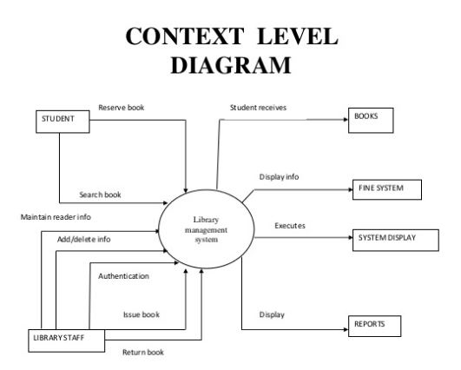

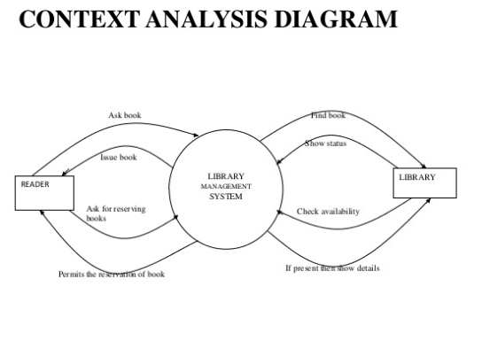

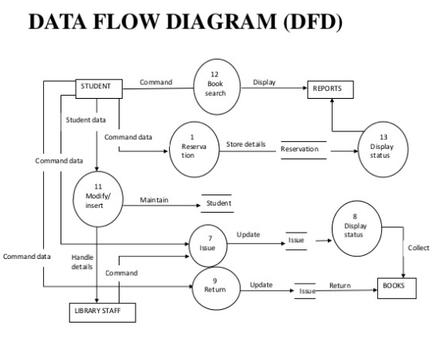

ENTITY RELATION DIAGRAM
The Entity-Relationship (E-R) data model is a widely used data model, and it provides convenient graphical representation to view data, relationship and constraints. This model is widely based on a perception of a real world that consists of a collection of basic objects, called entities, and relationships among these objects. Enhanced Entity-Relationship diagram along with some sample attributes are shown below:
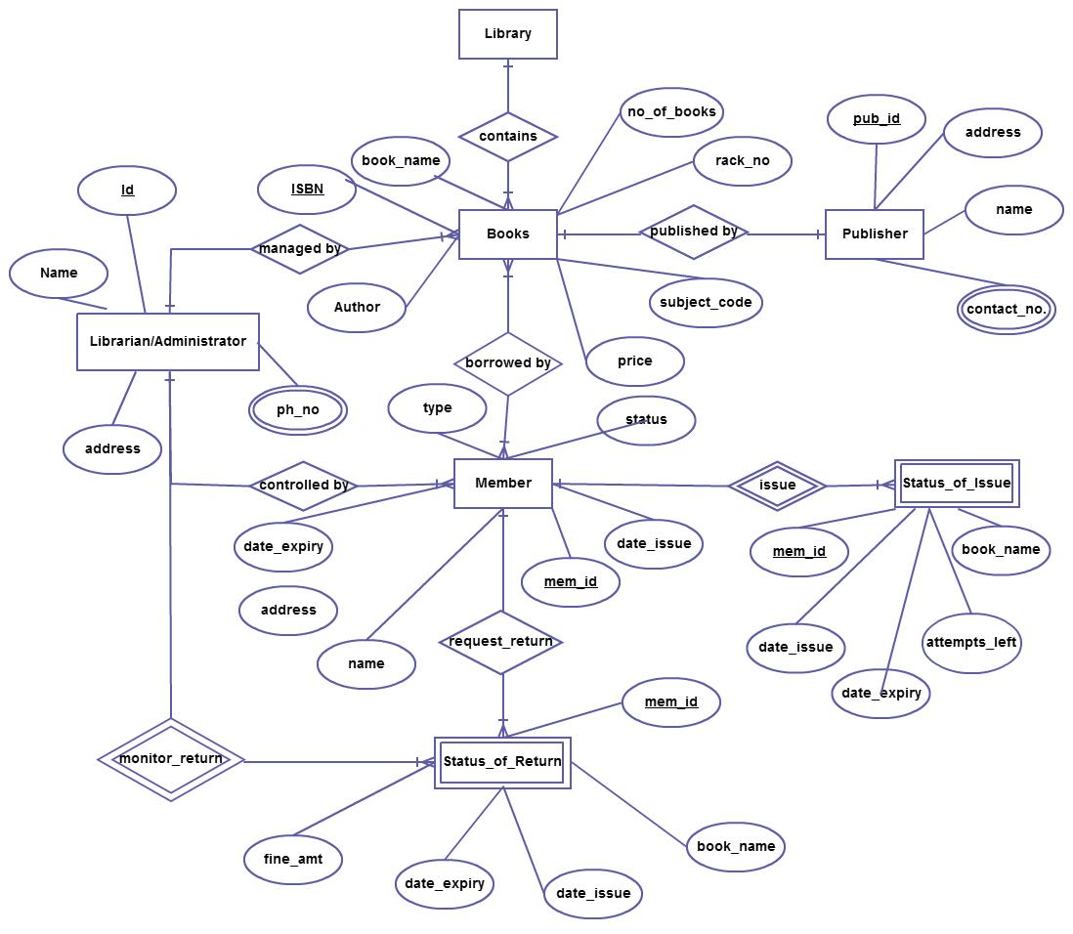

The Library System provides online real time information about the books available in the Library and the user information. The main purpose of this project is to reduce the manual work. This software is capable of managing Book Issues, Returns, Calculating/Managing Fine, Generating various Reports for Record-Keeping according to end user requirements. The Librarian will act as the administrator to control members and manage books. The member’s status of issue/return is maintained in the library database. The member’s details can be fetched by the librarian from the database as and when required. The valid members are also allowed to view their account information.

Software requirement specification
After the analyst has collected all required information regarding the software to be developed, and has removed all incompleteness, inconsistence, and anomalies from the specification, he starts to systematically organize the requirements in the form of an SRS document. The SRS document usually contains all the user requirements in an informal form.
Many software engineers in a project consider the SRS document as a reference document. However, it is often more appropriate to think of the SRS document as the documentation of a contract between the customer and the development teem. In fact the SRS document can be used to resolve any disagreement between developer and the customers which may arise in the future. The SRS document can even be used as a legal document to settle disputes between the customers and the developers. Once the customer agree to the SRS document, the development teem proceeds to develop product conforming to all requirement mentioned in the SRS document.
There is no doubt that the mode of specification has much to do with the quality of solution. Software engineers who have been forced to work with incomplete, inconsistent or misleading specifications have experienced the frustration and confusion that invariably results. Specification, regardless of the
Software requirement specification Document
Introduction:-
Functional requirement: -The requirement of this function has been implemented on the basis of the project designing and partitioning the Project into different sub-modules, which are as follows:
Functional Partitioning:
- Login interface.

- Create a new account module.

- Manage student

- Manage books

- Issues books

- Return books

Functional Description:A description of each function required to solve the problem is presented in the functional description.

- Login interface: Take User ID and Password.

- Create a new account module: New account can be created with new user name and password

DATABASE STRUCTURE

FOR STUDENT_REGISTRATION
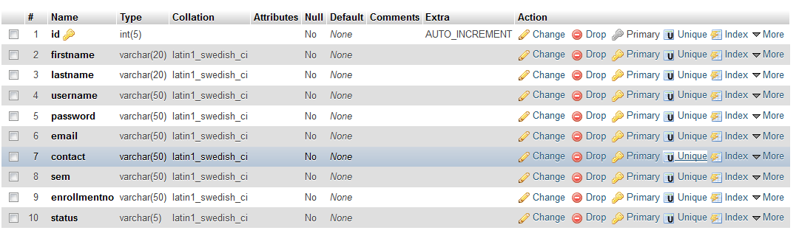

FOR LIBRARIAN_REGISTRATION
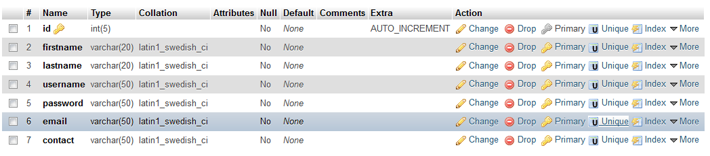
FOR ADD_BOOKS
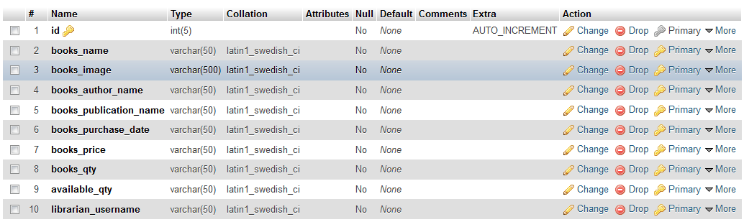

FOR ISSUE_BOOKS
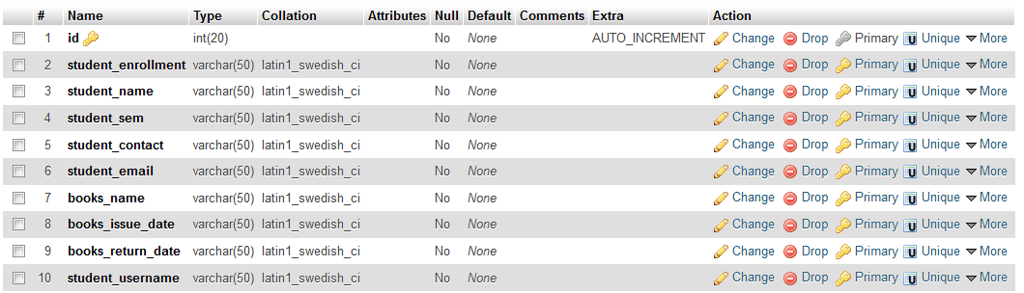
FOR NEWS

FOR PAGE
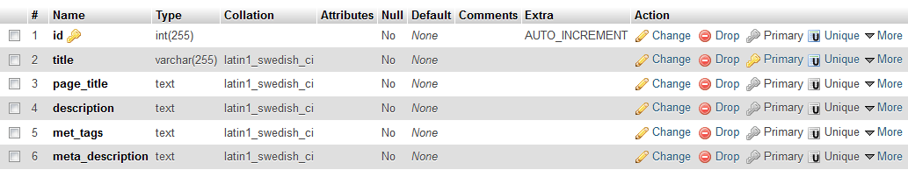
FOR NEWS
FOR CONTACT_US
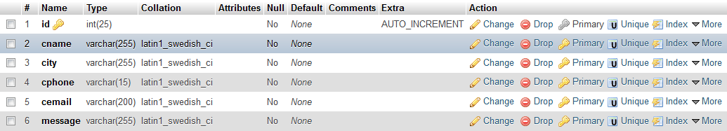

MODEL

Iterative Waterfall Model:The linear or waterfall model is a development work that centers around plan work and is best suited for project where the requirements can be easily defined. We decided to use this process model because we received the data and information required for the project work, not at a time but partially into a sequence of consecutive phases ,due to the busy schedule of the firm in their office hours. So the requirements were not completely specified before we could start the development process. In the Iterative Waterfall Model the basic idea is that each phase in the software are in a sequence that can only comments after the previous phase space has been completed. Each phase usually produces more and more models or product in later phase. The model becomes the part of the phase report which described what has been achieved in this phase and outlines a plan for the next phase. The reports also include many models, new or expanded user requirements, design decisions and problems encountered. This information is used as the input for the next phase. Phase reports are also used to keep management inform of the project progresses so that the management can use the reports to change the project direction and to allocate resources to the project.
An advantage of this approach is that it can result in better testing because testing each increment is likely to be easier than testing the entire system as in the classical waterfall model. There are three phases in iterative waterfall model; the design phase, implementation phase and analysis phase.

Feasibility Study

Requirements analysis And Specification

Design

Coding And Unit Testing

Integration And System Testing

Maintenance&Implementation.

DESIGN SNAPSHOT

MAIN PAGE
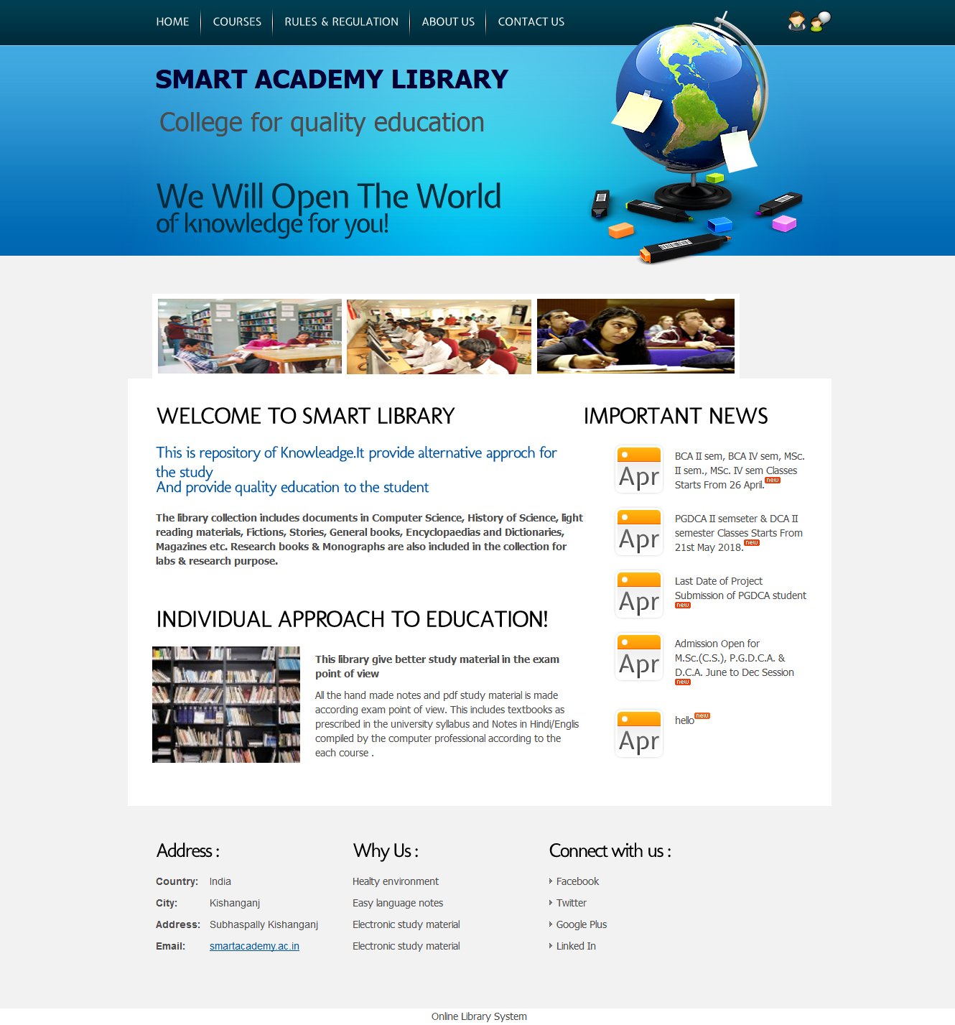
LOGIN PAGE
LIBRARIAN LOGIN
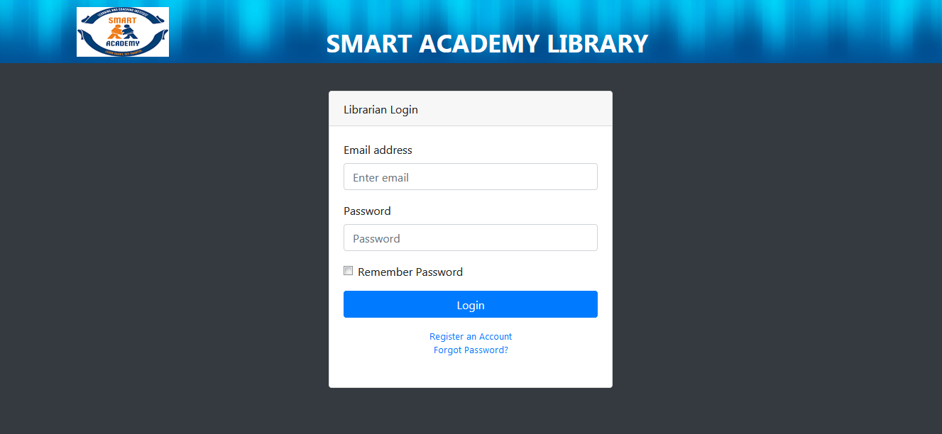
STUDENT LOGIN
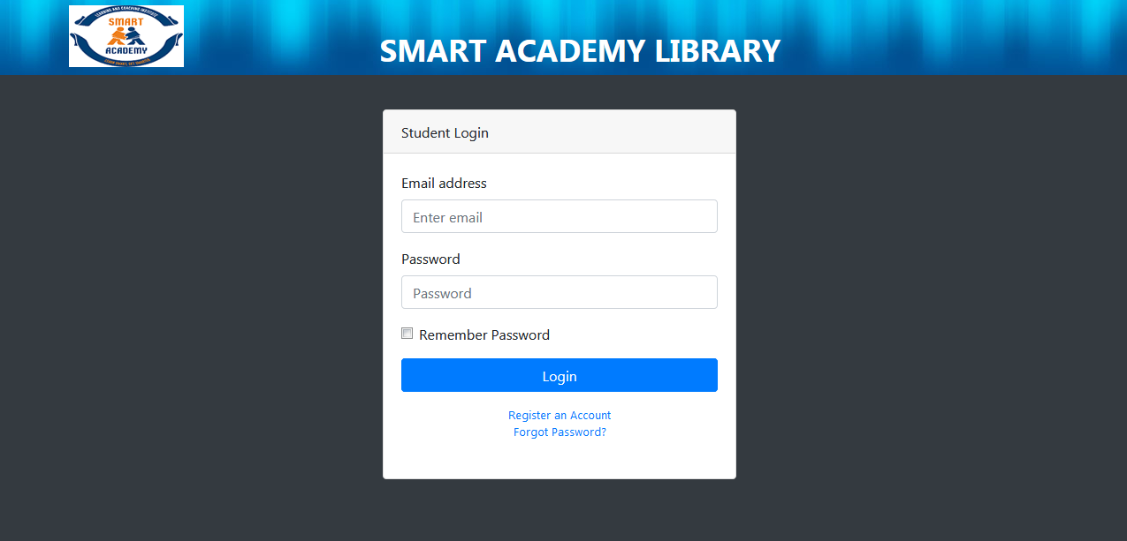

REGISTRATION PAGE
LIBRARIAN REGISTRATION
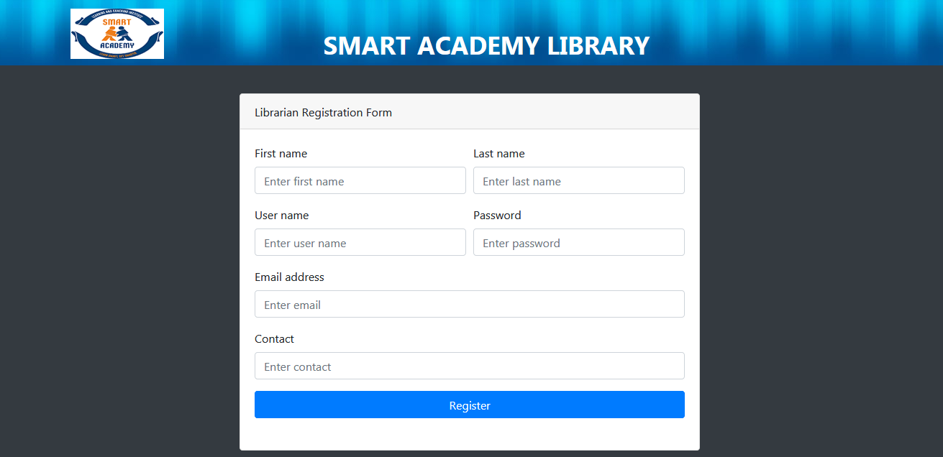
STUDENT REGISTRATION
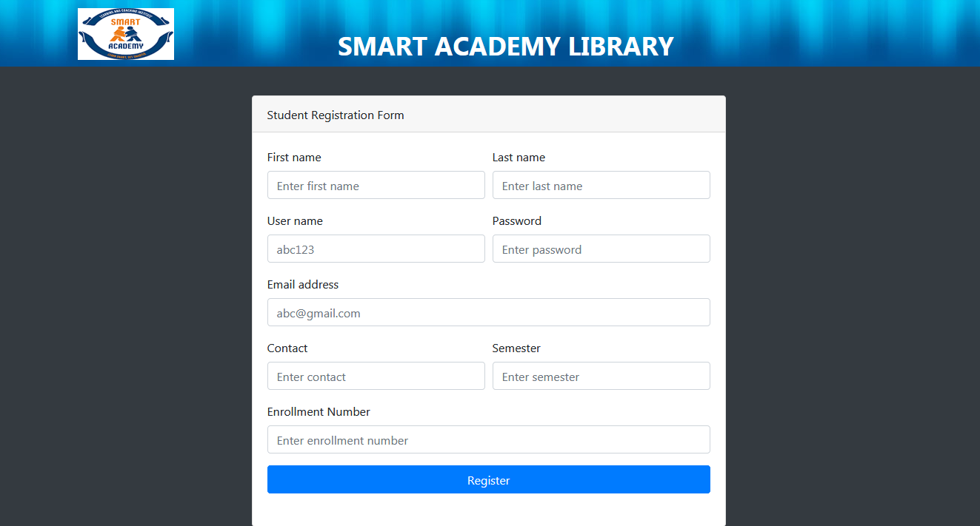
WELCOME PAGE
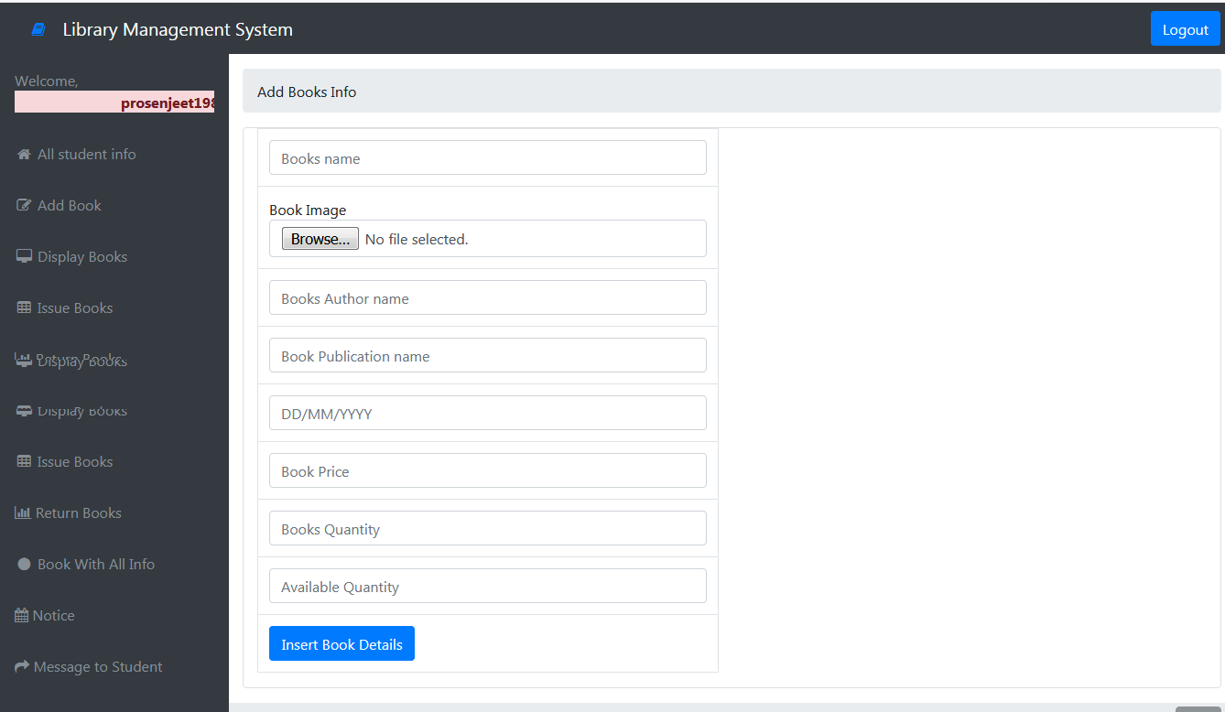
STUDENT INFORMATION
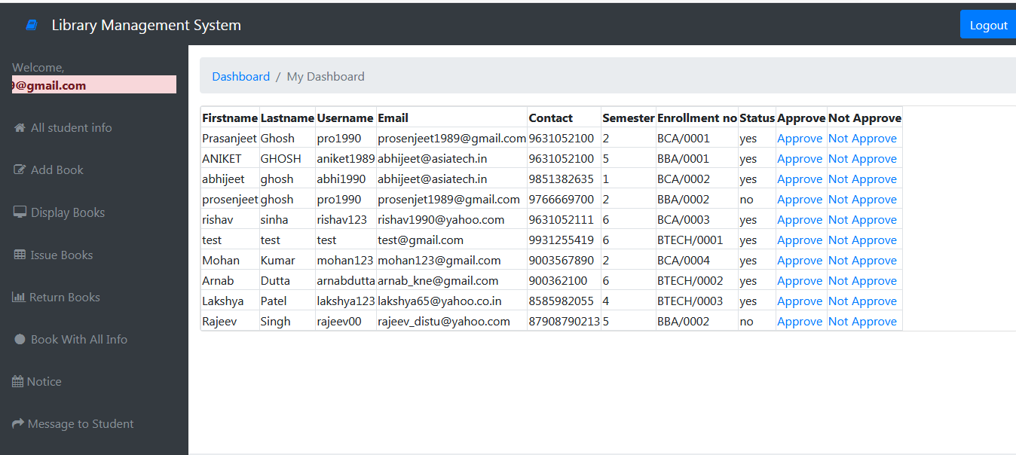
BOOK INFORMATION
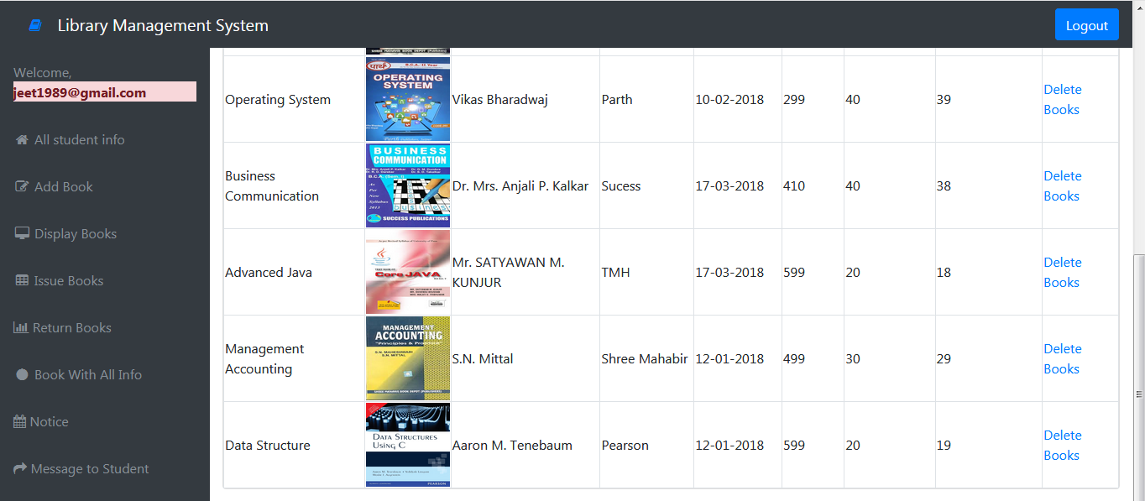
ISSUE BOOK INFORMATION
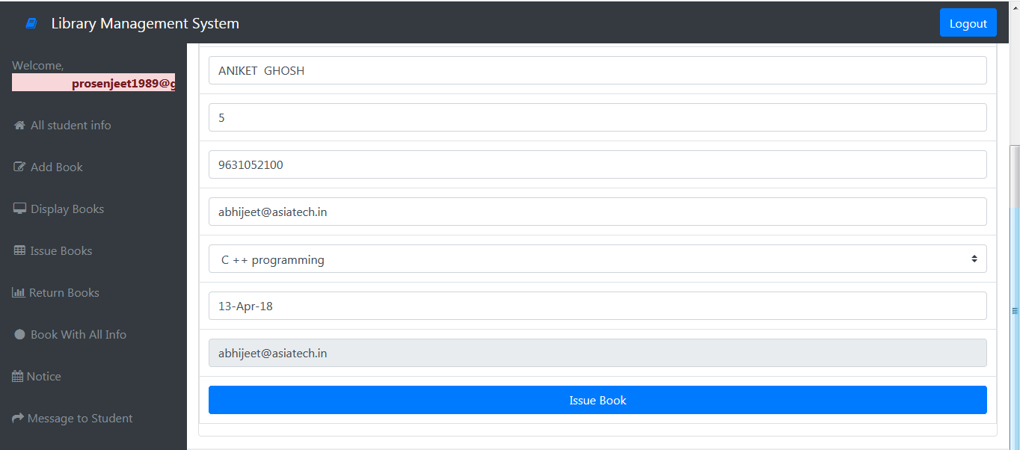

BOOK WITH DETAILS
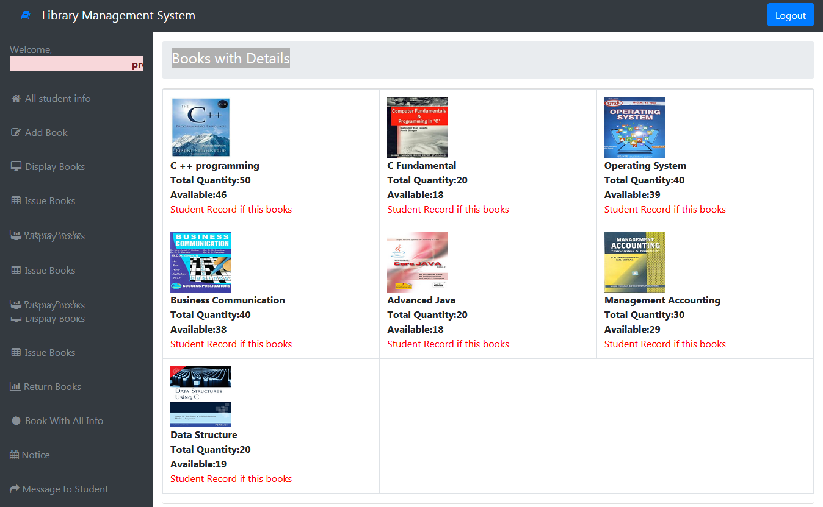

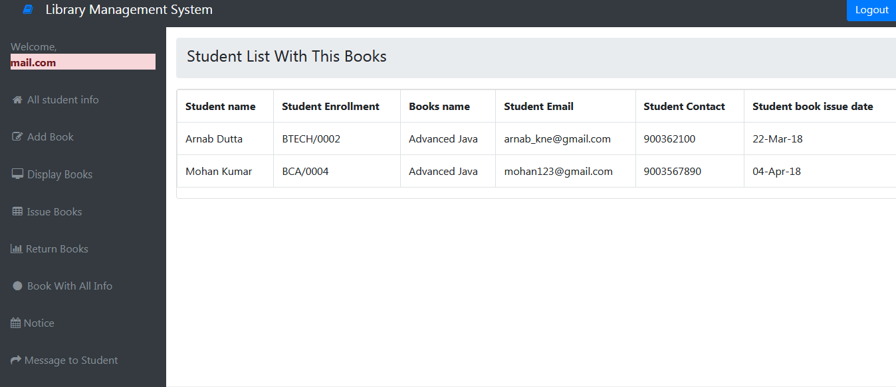

RETURN BOOKS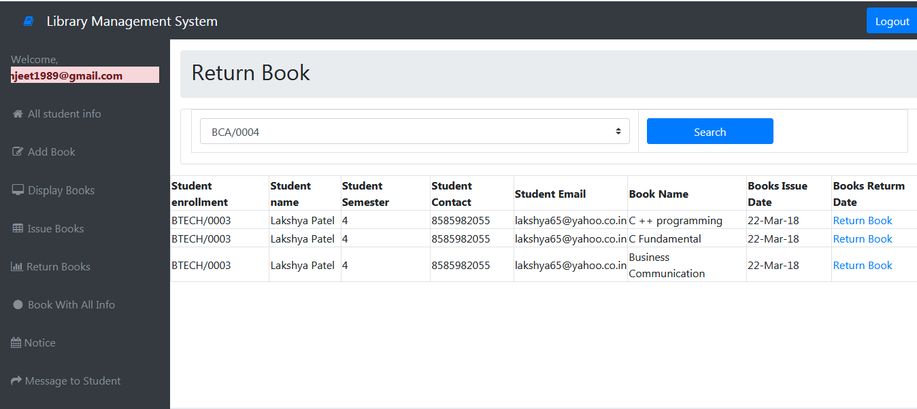

CODING
Login Coding
<?php
session_start();
include("../connection/connection.php");
?>
<!DOCTYPE html>
<html lang="en">

<head>
<style>
.header-main {
background: #005195 url(../images/header-bg.jpg) repeat-x top left;
height: 94px;
}

#header-main #logo
{}
#header-main #logo img{

width: 130px;
height: 60px;
float:left;
margin:10px 0px 0px0px;
padding:0px;
float:left;
border-radius: 70px ;
-moz-border-radius: 70px ;
-webkit-border-radius: 70px ;
}
span#companyname
{

font-size:35px;
font-weight:bold;
color:#fff;
float:left;
margin-right:305px;
margin-top:16px;
line-height:25px;
padding:0px;
float:right;

}

</style>
<meta charset="utf-8">
<meta http-equiv="X-UA-Compatible" content="IE=edge">
<meta name="viewport" content="width=device-width, initial-scale=1, shrink-to-fit=no">
<meta name="description" content="">
<meta name="author" content="">
<title>Smart Academy Library System </title>
<!-- Bootstrap core CSS-->
<link href="../vendor/bootstrap/css/bootstrap.min.css" rel="stylesheet">
<!-- Custom fonts for this template-->
<link href="../vendor/font-awesome/css/font-awesome.min.css" rel="stylesheet" type="text/css">
<!-- Custom styles for this template-->
<link href="../css/sb-admin.css" rel="stylesheet">
</head>

<body class="bg-dark header-main">
<div class="container">
<div id="logo" style="margin-top:17px;">
<?php

$sql = "select * from setting where id = '1'";
$header = mysql_query($sql);
$rowheader = mysql_fetch_array($header);
if($rowheader['logo']!="")
{
echo '<imgsrc="../images/'.$rowheader['logo'].'">';
}else
{

}
?>
<span id="companyname" style="margin-top:37px;"><?php echo $rowheader['webtitle'] ;?></span>

</div>
<div class="card card-login mx-auto mt-5">
<div class="card-header"> Librarian Login</div>
<div class="card-body">
<form action="" method="post" name="form1">
<div class="form-group">
<label for="exampleInputEmail1">Email address</label>
<input name="email" class="form-control" id="exampleInputEmail1" type="email" aria-describedby="emailHelp" placeholder="Enter email">
<span class="error"></span>
</div>
<div class="form-group">
<label for="exampleInputPassword1">Password</label>
<input name="password" class="form-control" id="exampleInputPassword1" type="password" placeholder="Password">
<span class="error"></span>
</div>
<div class="form-group">
<div class="form-check">
<label class="form-check-label">
<input class="form-check-input" type="checkbox"> Remember Password</label>
</div>
</div>
<input class="btnbtn-primary btn-block" name="submit1" type="submit" value="Login" />
</form>
<div class="text-center">
<a class="d-block small mt-3" href="register.php">Register an Account</a>
<a class="d-block small" href="forgot-password.php">Forgot Password?</a>
</div>
<br/>
<?php
if(isset($_POST['submit1']))
{
$count=0;
$res=mysql_query("select * from librarian_registration where email='$_POST[email]' && password='$_POST[password]'");
$count=mysql_num_rows($res);

if($count==0)
{

?>
<div class=" alert alert-danger col-lg-12 col-lg-push-0"><imgsrc="../images/cross-on-white.gif" />
<strong style="color:red">Invalid Email address or Password.</strong>

</div>
<?php
}
else
{
$_SESSION["lib_user"]=$_POST["email"];
?>
<script type="text/javascript">
window.location="add_books.php";
</script>
<?php
}
}
?>
</div>
</div>
</div>
<!-- Bootstrap core JavaScript-->
<script src="../vendor/jquery/jquery.min.js"></script>
<script src="../vendor/bootstrap/js/bootstrap.bundle.min.js"></script>
<!-- Core plugin JavaScript-->
<script src="../vendor/jquery-easing/jquery.easing.min.js"></script>
</body>

</html>
User Registration:-
<?php
include("../connection/connection.php");
?>
<!DOCTYPE html>
<html lang="en">

<head>
<style>
.header-main {
background: #005195 url(../images/header-bg.jpg) repeat-x top left;
height: 94px;
}

#header-main #logo
{}
#header-main #logo img{

width: 130px;
height: 60px;
float:left;
margin:10px 0px 0px0px;
padding:0px;
float:left;
border-radius: 70px ;
-moz-border-radius: 70px ;
-webkit-border-radius: 70px ;
}
span#companyname
{

font-size:35px;
font-weight:bold;
color:#fff;
float:left;
margin-right:305px;
margin-top:16px;
line-height:25px;
padding:0px;
float:right;

}

</style>
<meta charset="utf-8">
<meta http-equiv="X-UA-Compatible" content="IE=edge">
<meta name="viewport" content="width=device-width, initial-scale=1, shrink-to-fit=no">
<meta name="description" content="">
<meta name="author" content="">
<title>Smart Academy Library System </title>
<!-- Bootstrap core CSS-->
<link href="../vendor/bootstrap/css/bootstrap.min.css" rel="stylesheet">
<!-- Custom fonts for this template-->
<link href="../vendor/font-awesome/css/font-awesome.min.css" rel="stylesheet" type="text/css">
<!-- Custom styles for this template-->
<link href="../css/sb-admin.css" rel="stylesheet">
</head>

<body class="bg-dark header-main">
<div class="container">

<div id="logo" style="margin-top:17px;">
<?php

$sql = "select * from setting where id = '1'";
$header = mysql_query($sql);
$rowheader = mysql_fetch_array($header);
if($rowheader['logo']!="")
{
echo '<imgsrc="../images/'.$rowheader['logo'].'">';
}else
{

}
?>
<span id="companyname" style="margin-top:37px;"><?php echo $rowheader['webtitle'] ;?></span>

</div>
<div class="card card-register mx-auto mt-5">
<div class="card-header">Librarian Registration Form</div>
<div class="card-body">
<form action="" method="post" name="form1">
<div class="form-group">
<div class="form-row">
<div class="col-md-6">
<label for="exampleInputName">First name</label>
<input name="firstname" class="form-control" id="exampleInputName" type="text" aria-describedby="nameHelp" placeholder="Enter first name" required="required">
</div>
<div class="col-md-6">
<label for="exampleInputLastName">Last name</label>
<input name="lastname" class="form-control" id="exampleInputLastName" type="text" aria-describedby="nameHelp" placeholder="Enter last name" required="required">
</div>
</div>
</div>
<div class="form-group">
<div class="form-row">
<div class="col-md-6">
<label for="exampleInputUser">User name</label>
<input name="username" class="form-control" id="exampleInputUser" type="text" aria-describedby="nameHelp" placeholder="Enter user name" required="required">
</div>
<div class="col-md-6">
<label for="exampleInputPassword">Password</label>
<input name="password" class="form-control" id="exampleInputPassword" type="password" aria-describedby="nameHelp" placeholder="Enter password" required="required">
</div>
</div>
</div>
<div class="form-group">
<label for="exampleInputEmail1">Email address</label>
<input name="email" class="form-control" id="exampleInputEmail1" type="email" aria-describedby="emailHelp" placeholder="Enter email" required="required" >
</div>
<div class="form-group">

<label for="exampleInputContact">Contact</label>
<input name="contact" class="form-control" id="exampleInputContact" type="text" placeholder="Enter contact">

</div>

<input class="btnbtn-primary btn-block" name="submit1" type="submit" value="Register" />

</form>
<br/>
<?php
if(isset($_POST['submit1']))
{
$sql_ins=mysql_query("insert into librarian_registration values('','$_POST[firstname]','$_POST[lastname]','$_POST[username]','$_POST[password]','$_POST[email]','$_POST[contact]')");

if($sql_ins==true)
{
?>
<div class="alert alert-success col-lg-12 col-lg-push-0">
Registration Successfully,You will get email when your account is approved.
</div>
<?php
}

}
?>

<!--<div class="text-center">
<a class="d-block small mt-3" href="login.html">Login Page</a>
<a class="d-block small" href="forgot-password.html">Forgot Password?</a>
</div>-->
</div>

</div>
</div>
<!-- Bootstrap core JavaScript-->
<script src="../vendor/jquery/jquery.min.js"></script>
<script src="../vendor/bootstrap/js/bootstrap.bundle.min.js"></script>
<!-- Core plugin JavaScript-->
<script src="../vendor/jquery-easing/jquery.easing.min.js"></script>
</body>

</html>

TESTING

The aim of program testing is to identify all defects in a program. However, in practice, even after satisfactory completion of the testing phase, it is not possible to guarantee that a program is error free. This is because the input data domain of most programs is very large, and it is not practical to test the program exhaustively with respect to each value that the input can assume.
A software product is normally tested in three levels or stages:
- Unit testing
- Integration testing
- System testing
Unit testing: - Unit testing is referred to as testing in small, whereas integration and system testing are referred to as testing in the large. Unit testing is undertaken after a module has been coded and reviewed. Before carrying out unit testing, the unit test cases have to be designed and the test environment for the unit under test has to be developed.
BLACK –BOX TESTING: - In black-box testing, test cases are designed from an examination of the input/output values only and no knowledge off design or code is required. The following are the two main approaches available to design black-box test cases:
- Equivalence class partitioning
- Boundary value analysis
- EQUIVALENCE CLASS PARTITIONING: - In the equivalence class partitioning approach, the domain of the input values to the program under test is partitioned into a set of equivalence classes. The partitioning is done such that for every input data belonging to the same equivalence class, the programs behave similarly. The main idea behind defining equivalence classes of input data is that testing the code with any one value belonging to an equivalence class is as good as testing the code with any other value belonging to the same equivalence class.
- BOUNDARY VALUE ANALYSIS: - Boundary value analysis-based test suite design involves designing test cases using the values at the boundaries of different equivalence classes. A type of programming error that is frequently committed by programmers is missing out on the special consideration that should be given to the values at the boundaries of different equivalence classes of inputs. The reason behind programmers committing such errors might purely be due to psychological factors. For example, programmers may improperly use < instead of <=, or conversely <= for <, etc.
WHITE-BOX TESTING:-White-box testing is an important type of unit testing. A large number of white-box testing strategies exist. Each testing strategy essentially designs test cases based on analysis of some aspect of source code and is based on some heuristic.
A white-box testing strategy can either be coverage-based or fault based.
- FAULT-BASED TESTING:- A fault-based testing strategy targets to detect certain types of faults. These faults that a test strategy focuses on constitutes the fault model of the strategy. An example of a fault based strategy is mutation testing.

- COVERAGE-BASED TESTING: - A coverage based testing strategy attempts to execute certain elements of a program. Popular example of coverage-based testing strategies are statement coverage, branch coverage, and path coverage based testing.
- INTEGRATION TESTING: - Integration testing is carried out after all (or at least some of) the modules have been unit tested. Successful completion of unit testing, to a large extent, ensures that the unit (or module) as a whole work satisfactorily. The objectives of the integration testing is to detect the errors at the module interfaces (call parameters).Its objectives is to check whether the different modules of a program interface with each other properly.
During integration testing, different modules of a system are integrated in a planned manner using an integration plan. The following approaches can be used to develop the test plan:
- Big bang approach
- Top-down approach
- Bottom-up approach
- Mixed approach
BIG BANG APPROACH: - Big bang testing is the most obvious approach to integration testing. In this approach all the modules making up a system are integrated in a single step. In the simple words, all the modules of the system are simple linked together and tested. However, this technique can meaningfully be used only for very small systems. The main problem with this approach is that once an error is found during an integration testing, it is very difficult to identify the error as the error may potentially lie in any of the modules.
TOP-DOWN APPROACH:- Top down integration testing starts with the root module and one or two subordinate modules in the system. After the top level skeleton has been tested, the modules that are at the immediate lower level of the skeleton are combined with it and tested. An advantage of top down integration testing is that it requires writing only stubs, and stubs are simpler to write compared to drivers. A disadvantages of the top down integration testing is that in the absence of the lower level routines, many times it may become difficult to exercise the top level routines in the desired manner since the lower level routines perform several low level functions such as the input/output (O/I) operations.
BOTTOM-UP APPROACH:- Large software products are often made up of several subsystems. A subsystem might consist of many modules which communicate among each other through well defined interfaces. In bottom up integration testing, first the modules for the each subsystem are integrated. Thus the subsystems can be integrated separately and independently. The principal advantage of bottom up integration testing is that several disjoint subsystems can be tested simultaneously. Another advantage is that the low level modules get tested thoroughly, since they are exercised in each integration steps. A disadvantages is that the complexity that occurs when the system is made up of a number of small subsystems that are at the same level.
MIXED APPROACH: - The mixed also called sandwich integration testing follows a combination of top down and bottom up testing approaches. In top-down approach, testing can start only after the top levelmodules have been coded and unit tested. Similarly, bottom-up testing can start only after the bottom level modules are ready. In the mixed test approach, testing can start as and when modules become available after unit testing. Therefore, this is one of the most commonly used integration testing approaches. In this approach, both stubs and drivers are required to be designed.
- SYSTEM TESTING: - System tests are designed to validate a fully developed system to assure that it meets its requirements. The test cases are therefore designed solely based on the SRS document. After all the units of a program have been integrated together and tested, system testing is taken up. The system testing procedures are the same for both object oriented and procedural programs, since system test cases are designed solely based on SRS document and the actual implementation is immaterial.
There are essentially three kinds of system testing:
- ALPHA TESTING: - Alpha testing refers to the system testing carried out by the test team within the developing organization.
- BETA TESTING: - Beta testing is the system testing performed by a select group of friendly customers.
- ACCEPTANCE TESTING: - Acceptance testing is the system testing performed by the customer to determine whether he should accept the delivery of the system.
The system test cases can be classified into functionality and performance test cases.
The functionality tests are designed to check whether the software satisfies the functional requirement as documented in SRS document.
Performance testing is carried out to check whether the system meets the non-functional requirements identified in the SRS document.

BIBLIOGRAPHY
At the time of development of the software” LIBRARY MANAGEMENT SYSTEM”, we have used many resources and for that we are very thankful to all the people concerned.
Given below are the names of some important books, from which we have taken help in many ways:
Books:-
- “Database Management System” – Elmasri and Navathe.
- “Beginning PHP 5.3” – Matt Doyle.
- “PHP 5 /MYSQL Programming” – Andy Harris.

Websites:-
- http://wikipedia.com
- http://www.codeacademy.com
- http://www/.w3schools.com/php
- www.learnphp.com
- www.sitepoint.com



